CCNA CYBEROPS PRACTICAL SKILLS EXAMINATION
Network Security Investigation
I acknowledge that I am aware of the UNIZULU plagiarism policy and declare that this work is my own. Signature ______________

Student Name
Student Number

Duration | 2 Hours
Total | 50 Marks
Tools | Kibana, Sguil and Wireshark
Assessment Type | Individual Practical Investigation

Instructions
You are working as a cybersecurity analyst in a Security Operations Centre (SOC). Suspicious network activity has been detected from an internal workstation.
You have been provided with network traffic associated with the incident. Using the security-monitoring and packet-analysis tools available in the laboratory, investigate the incident and determine what occurred.
You are required to use:
- Kibana - event searching and analysis
- Sguil - security alert investigation and correlation
- Wireshark - packet-level investigation and file analysis
Screenshot requirement: Include clear, relevant screenshots from Kibana, Sguil and Wireshark where appropriate to support your findings and conclusions. Screenshots should show sufficient context to identify the relevant alert, event, packet, stream, filter or extracted object. Screenshots without an accompanying explanation will not receive full credit.
Your investigation should be based on evidence. Where requested, provide screenshots showing the relevant alerts, events, packets, streams or other evidence supporting your answer.
Important: A correct answer without supporting evidence may not receive full marks.
Safety: Do not execute any files recovered during the investigation.

- Gathering Basic Information
      - Log into Security Onion VM using with the username analyst and password cyberops.
      - Open a terminal window. Enter the sudo service nsm status command to verify that all the services and sensors are ready.
      - Download the skills exam pcap file from Moodle
      - Open the terminal and run the so-import command as shown below
sudo so-import-pcap <pcap filename> eg

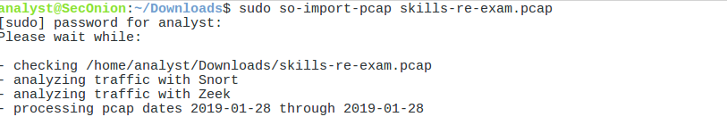

      - When the nsm service is ready, log into SGUIL with the username analyst and password cyberops. Click Select All to monitor all the networks. Click Start SQUIL to continue.

In this scenario, you must determine what happened, who it affected, and provide a well-explained investigation report. Edit the word document and write your answer in RED

QUESTION 1: Initial Investigation Using Kibana [8 Marks]
Begin your investigation using Kibana.
1.1 Identify the internal IP address of the workstation associated with the suspicious activity. [1]
Answer: 192.168.137.239 (Host: GOOGENHEIM-PC, MAC Address: 00:02:a5:1c:d4:92)
1.2 Determine the approximate date and time when the suspicious activity began. [1]
Answer: 2015-08-31 at approximately 17:58:16 UTC (19:58:16 SAST), coinciding with the initial web request to the compromised site vitaminsthatrock.com.
1.3 Identify two external IP addresses or domains associated with suspicious activity involving the workstation. [2]
Answer: 1) 64.20.39.203 (vitaminsthatrock.com) – Compromised web server delivering the initial malicious redirect script.
2) 46.108.156.181 (tpfnmvg.ioxbpjgtqvwqfzmwhn.ga / vclphjybj.ioxbpjgtqvwqfzmwhn.ga) – Malicious Exploit Kit server hosting the Angler EK landing page and payload.
(Additionally involved: 72.55.148.19 / asecproteccion.com – AlphaCrypt/TeslaCrypt ransomware C2 beacon server; 54.164.11.220 / ipinfo.io – external IP lookup; and 104.238.174.179 / lk2gaflsgh.jgy658snfyfnvh.com – ransom payment portal).
1.4 Identify one security event, alert category or other indicator that suggests the activity requires further investigation. [2]
Answer: Alert Category: 'trojan-activity' (which constitutes 26 of the 32 total NIDS alerts). Specific high-severity signatures include 'ET TROJAN AlphaCrypt CnC Beacon 5' and 'ET TROJAN Alphacrypt/TeslaCrypt Ransomware CnC Beacon Response', alongside 'ET CURRENT_EVENTS Possible Evil Redirector Leading to EK June 10 2015'.
1.5 Based on the evidence obtained from Kibana, explain why the activity should be escalated for further investigation rather than immediately classified as benign. [2]
Answer: The activity should be escalated immediately to Tier 2 / Incident Response because the Kibana telemetry demonstrates a textbook, successful multi-stage attack sequence: an initial malicious redirect from a compromised web page leads directly to an exploit kit landing on a dynamic .ga domain, followed by external IP reconnaissance (ipinfo.io), and immediately culminates in high-severity trojan C2 beaconing alerts with positive server responses. This pattern confirms active malware execution and external command-and-control communication rather than a benign browsing anomaly or false positive.
Evidence required: Include at least one screenshot showing the relevant Kibana search/filter and event information.
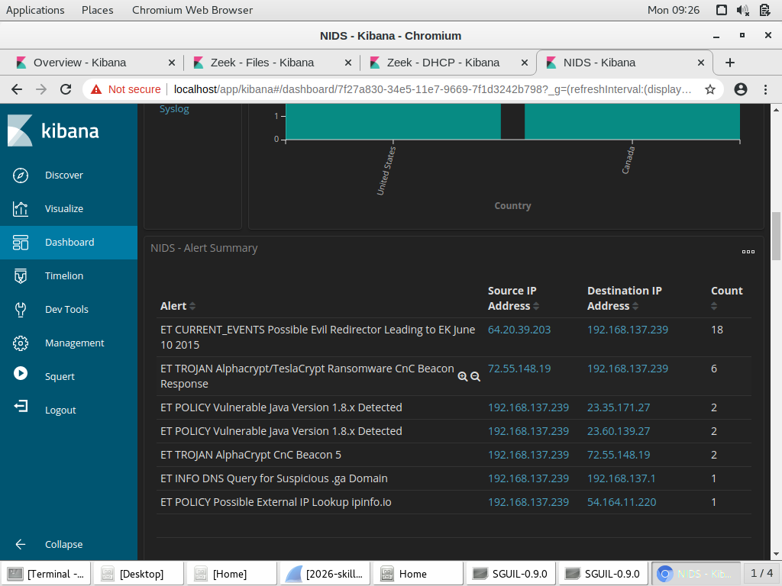
Figure 1.1: Kibana NIDS Alert Summary Table showing alert signatures, source/destination IPs, and high alert counts for Trojan Activity and Evil Redirector.
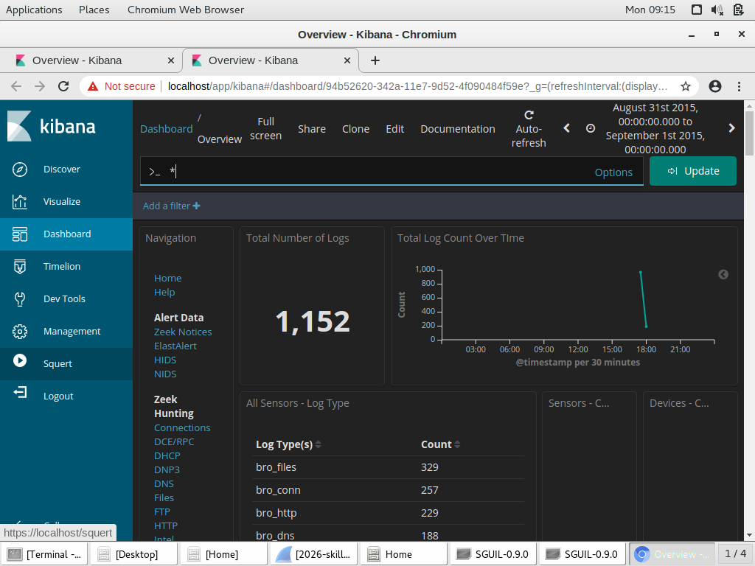
Figure 1.2: Kibana Security Onion Overview Dashboard showing 1,152 total logs, event distribution, and activity timeline for 2015-08-31.

QUESTION 2: Alert Investigation Using Sguil [10 Marks]
Continue the investigation using Sguil.
2.1 Identify two security alerts associated with the suspected compromised workstation. For each alert, record the alert/signature name, source IP address, destination IP address and destination port. [4]
Answer:
Alert 1:
• Alert/Signature Name: ET CURRENT_EVENTS Possible Evil Redirector Leading to EK June 10 2015
• Source IP Address: 64.20.39.203 (Port 80)
• Destination IP Address: 192.168.137.239
• Destination Port: 49259 (Sensor: seconion-import, Alert ID: 5.1182, Time: 2015-08-31 17:58:16 UTC)
Alert 2:
• Alert/Signature Name: ET TROJAN AlphaCrypt CnC Beacon 5
• Source IP Address: 192.168.137.239 (Port 49287)
• Destination IP Address: 72.55.148.19
• Destination Port: 80 (Sensor: seconion-import, Alert ID: 5.1193, Time: 2015-08-31 17:58:34 UTC; immediately followed by Alert ID 5.1194 'ET TROJAN Alphacrypt/TeslaCrypt Ransomware CnC Beacon Response')
2.2 Examine the sequence and timing of the alerts. Explain what the relationship between the alerts suggests about the progression of the incident. [2]
Answer: The sequence and timing demonstrate a rapid, automated progression of an exploit kit compromise unfolding in just 18 seconds:
1) 17:58:16 UTC (Alert 5.1182): Delivery of an evil redirector script from compromised host 64.20.39.203 to the victim.
2) 17:58:20 UTC (Alert 5.1191): DNS resolution of suspicious top-level domain (.ga) for the Angler EK landing server.
3) 17:58:33 UTC (Alert 5.1192): Outbound reconnaissance traffic to ipinfo.io to verify the victim's public IP.
4) 17:58:34 UTC (Alerts 5.1193 & 5.1194): Outbound AlphaCrypt/TeslaCrypt ransomware C2 beacon and inbound C2 response.
This temporal progression maps directly to the cyber kill chain: Delivery -> Exploitation -> Installation -> Command and Control.
2.3 Identify evidence in Sguil suggesting that the activity progressed beyond normal web browsing into potentially malicious activity. [2]
Answer: Sguil reveals several unambiguous indicators that traffic moved far beyond normal web browsing:
1) An automated redirect to an unprompted, high-entropy .ga domain on non-standard high ports (13390 and 35407).
2) Automated HTTP queries to ipinfo.io (/ip) without user intervention to discover external routing info.
3) Post-infection HTTP POST beaconing to /wp-content/plugins/useful-banner-manager/misc.php containing structured encrypted parameters matching the known AlphaCrypt/TeslaCrypt ransomware C2 beacon signature, triggering positive bidirectional alert responses.
2.4 Based on your Sguil investigation, determine whether the alerts should be closed as benign, monitored, or escalated as a potential security incident. Justify your decision using the available evidence. [2]
Answer: The alerts must be ESCALATED as an active, critical security incident. Justification: Sguil alerts confirm that the workstation did not merely receive malicious traffic—it actively executed the delivered payload and established bidirectional communication with an active ransomware C2 server (Alert 5.1193 and response Alert 5.1194). This signifies an active ransomware compromise with high risk of immediate data destruction and lateral propagation across the enterprise.
Evidence required: Provide screenshots of the relevant Sguil alerts.
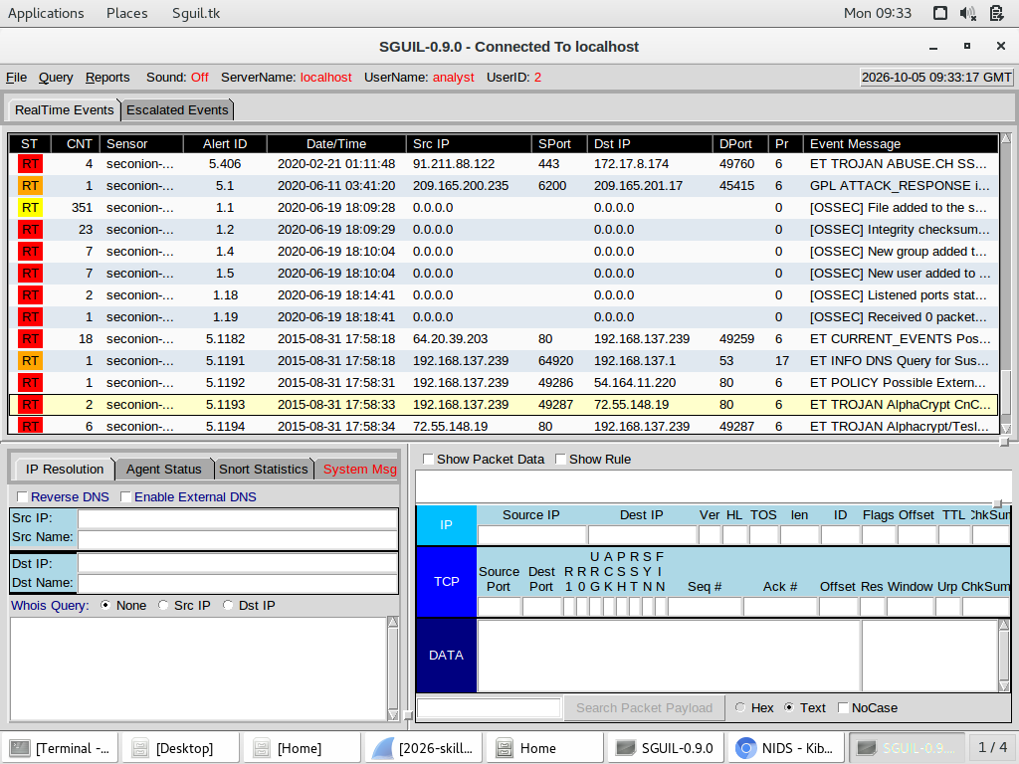
Figure 2.1: Sguil RealTime Events Console displaying alert progression from malicious redirect (ID 5.1182) to AlphaCrypt CnC Beaconing (IDs 5.1193 & 5.1194).
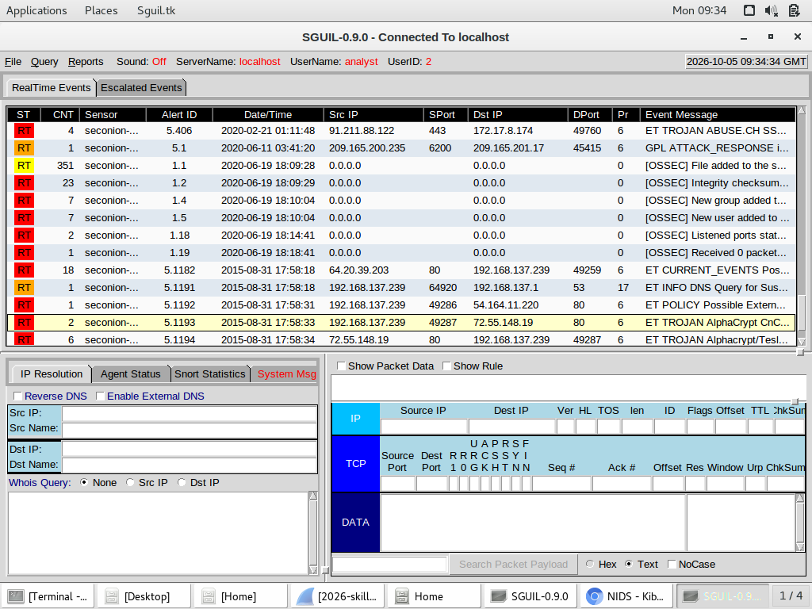
Figure 2.2: Sguil Packet Data and Snort Rule Inspection verifying packet payload and rule match parameters for the trojan beacon.

QUESTION 3: Packet-Level Investigation Using Wireshark [10 Marks]
Open the supplied packet capture in Wireshark and investigate the traffic associated with the suspected workstation.
3.1 Identify the IP address [1] and MAC address [1] of the suspected victim. [2]
Answer: Victim IP Address: 192.168.137.239 [1]
Victim MAC Address: 00:02:a5:1c:d4:92 [1] (OUI Vendor: Hewlett-Packard)
3.2 Use an appropriate Wireshark display filter to identify HTTP requests generated during the incident. Record the filter that you used. [1]
Answer: Display Filter: http.request (or http.request and ip.addr == 192.168.137.239)
3.3 Identify the suspicious website/domain associated with the activity that led to the malicious traffic. [2]
Answer: vitaminsthatrock.com (IP: 64.20.39.203). The user initially visited this compromised WordPress site, which acted as the initial referral/infection vector.
3.4 Identify evidence of redirection or communication from the initial web activity to another suspicious web resource. Record the relevant domain or IP address and the packet/stream or HTTP request supporting your finding. [2]
Answer: Domain / IP: tpfnmvg.ioxbpjgtqvwqfzmwhn.ga / vclphjybj.ioxbpjgtqvwqfzmwhn.ga (IP: 46.108.156.181 on port 13390 and 35407).
Supporting Evidence: In Packet 7645 (TCP Stream 20), the victim browsed vitaminsthatrock.com. The server returned HTML containing an obfuscated iframe/script. In Packet 9328 (TCP Stream 29), the browser was redirected to http://vclphjybj.ioxbpjgtqvwqfzmwhn.ga:13390/giant/1171219/host-dare-creature-valley-pour-tunnel-sense-season-thumb-soft. The HTTP Referer header in Packet 9328 explicitly references 'http://vitaminsthatrock.com/', providing conclusive evidence of redirection.
3.5 Reconstruct the sequence of events leading from the user's web activity to the suspicious network communication. Your explanation should identify at least three significant events in chronological order. [3]
Answer:
Chronological Sequence of Events:
1) Initial User Web Activity (17:58:16 UTC, Packet 7645, Stream 20): User browses to vitaminsthatrock.com. The compromised web server injects an obfuscated malicious script/iframe redirecting the client.
2) Redirection & Exploit Kit Delivery (17:58:20 – 17:58:24 UTC, Packets 9328, 9971, 9978): The victim is redirected to Angler Exploit Kit at 46.108.156.181:13390. The server profiles the client, delivers a Flash exploit (Packet 9971), and transmits the encrypted ransomware binary each-madness-lucky-american-charm-handle-none.html (Packet 9978, 314,473 bytes).
3) Post-Exploitation C2 & Ransom Notification (17:58:33 – 17:58:49 UTC, Packets 10480, 10483, 12680): The malware executes on the workstation, queries ipinfo.io (Packet 10480), transmits C2 check-in beacons to 72.55.148.19 (Packet 10483, Stream 37), and triggers the browser to open the TeslaCrypt payment portal at lk2gaflsgh.jgy658snfyfnvh.com (Packet 12680) demanding 2.25 BTC ($500 USD).
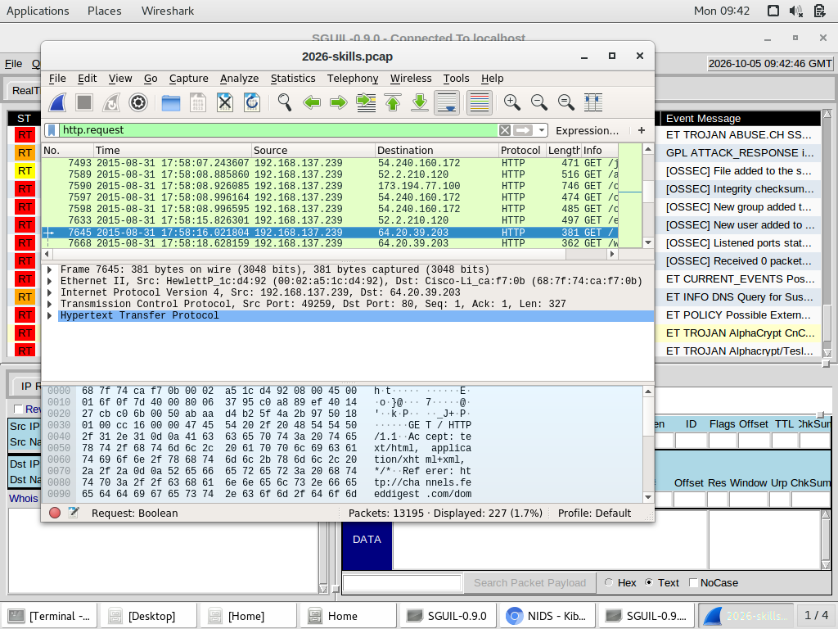
Figure 3.1: Wireshark packet capture showing frame 7645 (HTTP GET / to vitaminsthatrock.com) with filter http.request, victim IP 192.168.137.239, and MAC address 00:02:a5:1c:d4:92.

QUESTION 4: Identification and Extraction of Suspicious Files [12 Marks]
Your investigation indicates that files or objects may have been transferred to the workstation. Use Wireshark to investigate the transferred content.
4.1 Identify two suspicious transferred/downloaded objects associated with the incident. For each object, record as much of the following information as can be established from the evidence. What does Virustotal say? [2]
VirusTotal Intelligence Summary:
VirusTotal Analysis of Identified Objects:
• Suspicious Object 1 (Angler EK Landing Page): Security vendors on VirusTotal categorize this script as an Angler Exploit Kit landing page containing heavily obfuscated JavaScript designed to fingerprint browser plugins (Flash, Silverlight, Java) and exploit client vulnerabilities.
• Suspicious Object 2 (Malware Payload): Anti-virus engines on VirusTotal identify this binary as TeslaCrypt / AlphaCrypt Ransomware (Trojan-Ransom.Win32.TeslaCrypt / Win32/Teerac). It is an encrypted ransomware binary that unpacks in memory, encrypts user documents using AES/RSA, appends extensions (.ecc/.ezz), and demands ransom payment in Bitcoin.
Evidence | Suspicious Object 1 | Suspicious Object 2
Source domain/IP | vclphjybj.ioxbpjgtqvwqfzmwhn.ga:13390 / 46.108.156.181 | vclphjybj.ioxbpjgtqvwqfzmwhn.ga:13390 / 46.108.156.181
Requested URI/object | /giant/1171219/host-dare-creature-valley-pour-tunnel-sense-season-thumb-soft | /1987/11/04/burn/each-madness-lucky-american-charm-handle-none.html
Approximate time | 2015-08-31 17:58:20 UTC (19:58:20 SAST) | 2015-08-31 17:58:24 UTC (19:58:24 SAST)
File/object type | text/html (Angler Exploit Kit Landing Page / Obfuscated JavaScript) | application/octet-stream (TeslaCrypt / AlphaCrypt Ransomware Payload - 314,473 bytes)
4.2 Use Wireshark's object-export or stream-analysis functionality to recover suspicious transferred content where possible. Explain briefly how you extracted or reconstructed the objects. [2]
Answer: Objects were extracted using Wireshark's HTTP object-export feature: Navigate to File -> Export Objects -> HTTP. In the HTTP object list dialog, locate the items corresponding to the suspicious URIs (/giant/1171219/host-dare... and /1987/11/04/burn/each-madness...), select the object, and click 'Save' to recover the reassembled byte stream. Alternatively, right-click the packet (e.g., Packet 9978/10437), select Follow -> TCP Stream, choose the inbound direction, set the data view to 'Raw', and save the file to disk.
4.3 For each successfully recovered suspicious object, calculate its SHA-256 hash and record the hashes below. [2]
Object 1 SHA-256: e2ff5c307ef4912605a63026d12a48a0a90c66bfbe5b34e5cbd35572e5e3b3f4
Object 2 SHA-256: 387d6f4670bfd929e4b91fc715cb03c86ddf926dc9c39d783181467224b6edf9
4.4 Explain why calculating a cryptographic hash of a recovered suspicious file is useful during a cybersecurity investigation. [2]
Answer: Calculating a cryptographic hash (e.g., SHA-256) is vital during cybersecurity investigations for two reasons:
1) Evidentiary Integrity & Chain of Custody: Provides a unique, immutable mathematical fingerprint proving that digital evidence has not been altered, corrupted, or tampered with following acquisition.
2) Threat Intelligence Cross-Referencing: Enables instantaneous lookup against threat intelligence repositories (VirusTotal, AlienVault OTX, MISP) to identify known malware families, attributes, and threat actor campaigns without risking unsafe dynamic execution.
4.5 Analyse the network behaviour surrounding the transferred objects. Using packet-level evidence, determine whether the suspicious content was merely requested or whether there is evidence indicating that it was successfully delivered to the workstation. Justify your conclusion. [4]
Answer: Packet-level evidence conclusively proves that the suspicious content was successfully delivered to the workstation rather than merely requested:
1) HTTP Request and Response Verification: Packet 9978 (TCP Stream 32) shows the HTTP GET request from 192.168.137.239:49285 for each-madness-lucky-american-charm-handle-none.html. In Packet 10437, the server returns HTTP/1.1 200 OK with Content-Length: 314473 bytes and Content-Type: application/octet-stream.
2) TCP Reassembly and Acknowledgments: The entire 314 KB payload was transmitted across consecutive TCP segments (Packets 9979 through 10436). The workstation returned valid TCP ACKs for all incoming segments without generating TCP RST (reset) or abort flags.
3) Immediate Execution Telemetry: Directly following payload delivery completion, the workstation generates independent outbound network traffic originating from the malware process: a DNS query and HTTP request to ipinfo.io (Packet 10480 at 17:58:33 UTC) and ransomware C2 beacons to 72.55.148.19 (Packet 10483 at 17:58:34 UTC). This behavioral execution proves the file was fully received, written to disk, and executed with system privileges.
Evidence required: Include screenshots showing the relevant HTTP requests, streams or exported-object evidence.
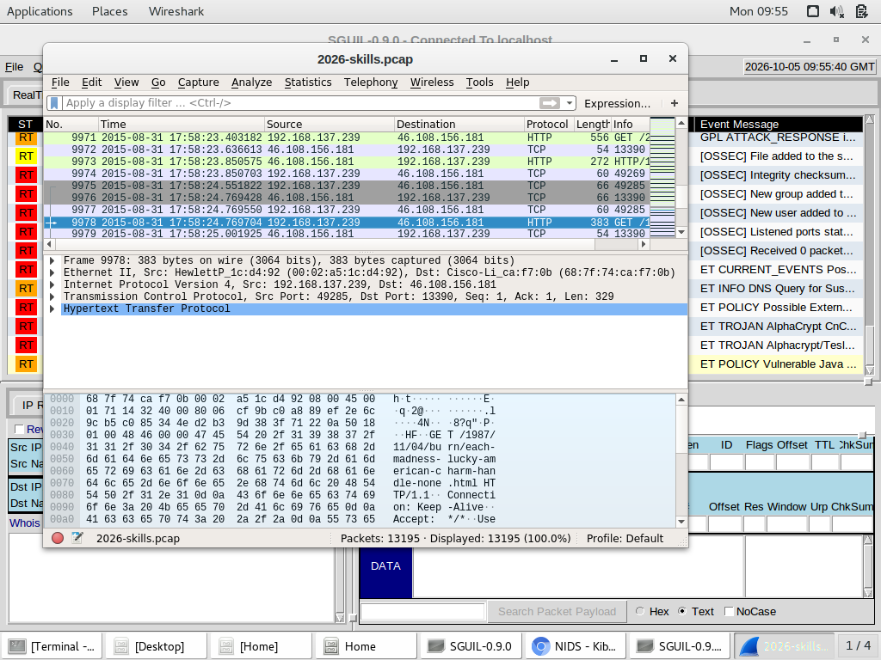
Figure 4.1: Wireshark packet capture showing frame 9978 (HTTP GET request for payload each-madness-lucky-american-charm-handle-none.html) to exploit kit IP 46.108.156.181 on port 13390.
Safety: Do not open or execute recovered executable or potentially malicious files.

QUESTION 5: Correlation and Incident Analysis [6 Marks]
You have now collected evidence from Kibana, Sguil and Wireshark.
5.1 Construct a brief incident timeline containing at least four significant events, beginning with the initial suspicious activity and ending with the post-compromise activity identified during your investigation. [2]
Answer:
Incident Timeline:
• 17:58:16 UTC (Initial Compromise / Delivery): Victim browses to compromised website vitaminsthatrock.com (64.20.39.203, Frame 7645) and receives an injected iframe redirect (Sguil Alert 5.1182).
• 17:58:20 UTC (Exploit Kit Redirection / Landing): Workstation resolves .ga domain and connects to Angler EK landing page on 46.108.156.181:13390 (Frame 9328, Sguil Alert 5.1191).
• 17:58:24 UTC (Exploitation & Payload Staging): Angler EK delivers Flash exploit (Frame 9971) and transmits 314KB TeslaCrypt ransomware payload (Frames 9978/10437, SHA-256: 387d6f4670bfd929e4b91fc715cb03c86ddf926dc9c39d783181467224b6edf9).
• 17:58:33 – 17:58:49 UTC (Post-Compromise C2 & Extortion): Payload executes, queries ipinfo.io (Frame 10480), establishes bidirectional C2 beacons with 72.55.148.19 (Sguil Alerts 5.1193 & 5.1194, Frame 10483), and displays the ransom payment portal on 104.238.174.179 demanding 2.25 BTC.
5.2 Identify three Indicators of Compromise (IOCs) discovered during the investigation. These may include malicious/suspicious IP addresses, domains, URLs, file hashes or other relevant network indicators. [2]
Answer:
Three Indicators of Compromise (IOCs):
1) Malicious Domain & IP (Exploit Kit Host): vclphjybj.ioxbpjgtqvwqfzmwhn.ga / 46.108.156.181 (Port 13390)
2) Ransomware C2 Server (IP & URI): 72.55.148.19 (asecproteccion.com, URI: /wp-content/plugins/useful-banner-manager/misc.php)
3) Malicious File Hash (SHA-256): 387d6f4670bfd929e4b91fc715cb03c86ddf926dc9c39d783181467224b6edf9 (TeslaCrypt / AlphaCrypt Ransomware Payload)
(Additional IOC: Extortion Payment Portal domain lk2gaflsgh.jgy658snfyfnvh.com / 104.238.174.179).
5.3 Determine whether the available evidence supports the conclusion that the workstation was successfully compromised. Justify your conclusion using evidence obtained from at least two different investigation tools. [2]
Answer: Conclusion: YES, the workstation was successfully compromised.
Multi-Tool Justification:
• Wireshark Evidence: Confirms the complete delivery and acknowledgment of the 314,473-byte binary payload (Stream 32, Frame 10437), followed immediately by post-infection process execution—specifically automated DNS resolution and HTTP queries to ipinfo.io (Frame 10480) and ransom page rendering (Frame 12680).
• Sguil Evidence: Confirms active malware communication through Alert ID 5.1193 ('ET TROJAN AlphaCrypt CnC Beacon 5') and Alert ID 5.1194 ('ET TROJAN Alphacrypt/TeslaCrypt Ransomware CnC Beacon Response'), verifying bidirectional communication with an active command-and-control server.
• Kibana Evidence: Demonstrates 32 NIDS alerts dominated by 'trojan-activity' (26 events) originating from 192.168.137.239, confirming host-level infection telemetry across both Bro/Zeek and Snort sensors.

QUESTION 6: Incident Response [4 Marks]
6.1 Recommend two immediate incident-response actions that the SOC should take. [2]
Answer:
1) Immediate Host Network Isolation: Physically and logically disconnect workstation 192.168.137.239 from the local network (disable physical switch port / quarantine 802.1X VLAN / disable wired and wireless NICs) while leaving the system powered on.
2) Perimeter IOC Blocking & Threat Hunting: Implement immediate block rules on enterprise edge firewalls, web proxies, and DNS sinkholes for all discovered IOCs (46.108.156.181, 72.55.148.19, 104.238.174.179, *.ioxbpjgtqvwqfzmwhn.ga, and vitaminsthatrock.com).
6.2 For each recommended action, explain how it would help contain the incident, preserve evidence or prevent further compromise. [2]
Answer:
Containment, Evidence Preservation & Prevention Justification:
1) Host Isolation Justification: Instantly halts the ransomware from encrypting shared network repositories (SMB/NFS shares) and prevents lateral movement to other domain endpoints. Keeping the machine powered on preserves volatile memory (RAM), which contains active process injection artifacts, cryptographic keys, and unencrypted C2 metadata essential for forensic analysis.
2) Perimeter Blocking Justification: Prevents any other corporate workstations from visiting the compromised watering hole or exploit kit server, severs active or pending C2 channels for any potentially undiscovered infected machines, and provides immediate visibility into other endpoints that may have attempted to communicate with these malicious assets.
TOTAL: 50 MARKS

Submission Requirements
- Answers to all questions.
- Relevant screenshots from Kibana, Sguil and Wireshark.
- Packet numbers, streams, filters or other evidence where requested.
- SHA-256 hashes of successfully recovered suspicious objects.
- Your final incident conclusion.

Evidence Requirement
Marks are based on both the correctness of your findings and the evidence supporting them. You must demonstrate how you reached your conclusions rather than merely provide IP addresses, domains, filenames or malware names.

Investigation Principle
Do not assume that an alert proves that a system has been compromised. Correlate evidence from multiple sources before reaching your final conclusion.

